**DAILY ONLINE ACTIVITIES SUMMARY**

|  |  |  |  |  |  |  |  |
| --- | --- | --- | --- | --- | --- | --- | --- |
| **Date:** | **28/05/2020** | | | | **Name:** | **Rohan Vashista BM** | |
| **Sem & Sec** | **6th Sem & B** | | | | **USN:** | **4al17CS078** | |
| **Online Test Summary** | | | | | | | |
| **Subject** | | **OS Test2** | | | | | |
| **Max. Marks** | | **30** | | **Score** | | **24** | |
| **Certification Course Summary** | | | | | | | |
| **Course** | **Full Stack Web development** | | | | | | |
| **Certificate Provider** | | | **Udemy** | **Duration** | | | **20hrs** |
| **Coding Challenges** | | | | | | | |
|  | | | | | | | |
| **Status: completed** | | | | | | | |
| **Uploaded the report in Github** | | | | **yes** | | | |
| **If yes Repository name** | | | | <https://github.com/Rohanvasista/Coding-activities> | | | |
| **Uploaded the report in slack** | | | | **yes** | | | |

**Online test details**

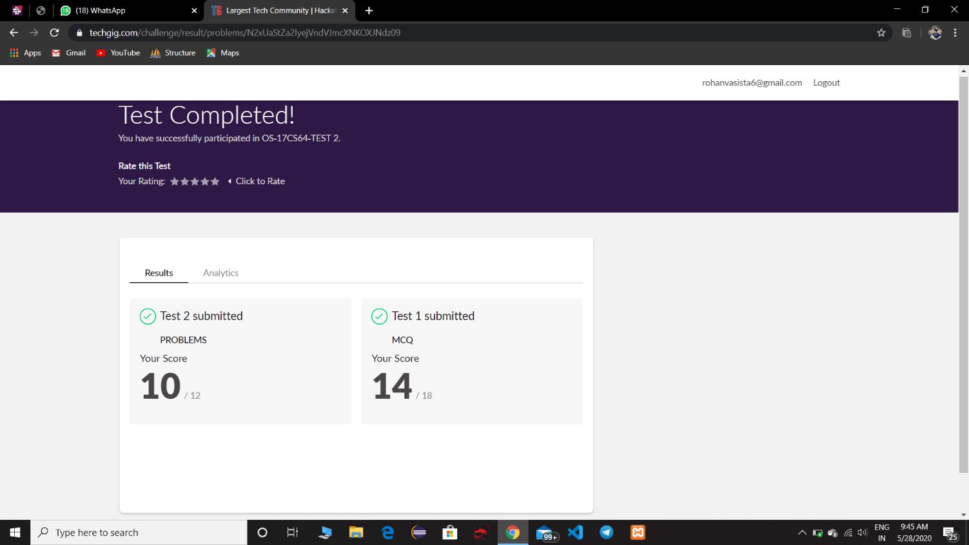

**Online Certification Details**

Completed modules

* Intoduction
* HTML
* CSS
* ReactJS
* Bootstrap
* Laravel

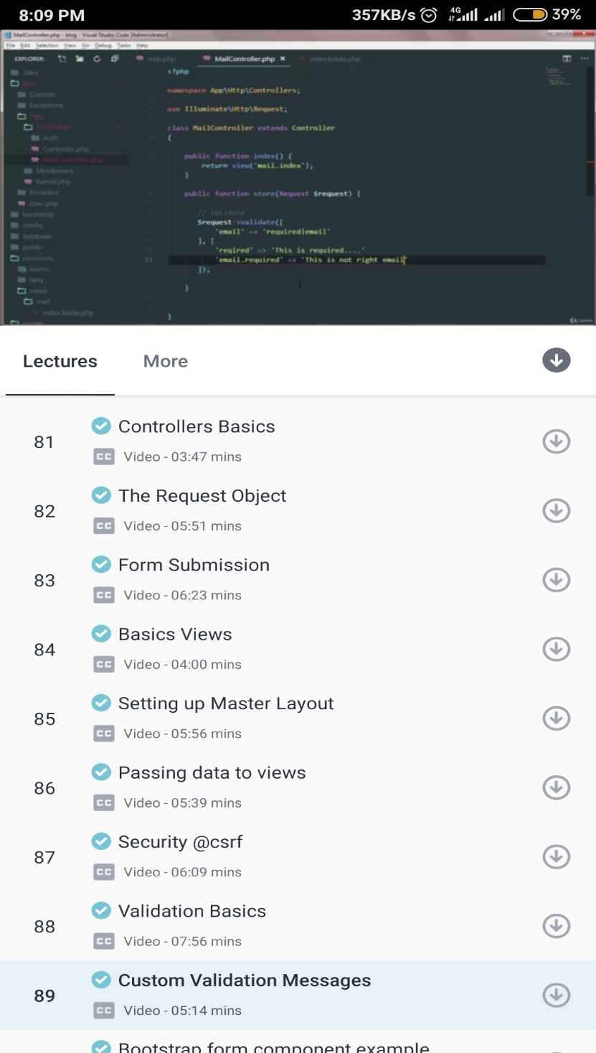

* Today I have learnt basics on controllers and its uses, Form submission, basics of views and validation basics.

**Coding Challenge Details**

1. This program checks for equal no of brackets is open and closed if so it prints true or else return false.

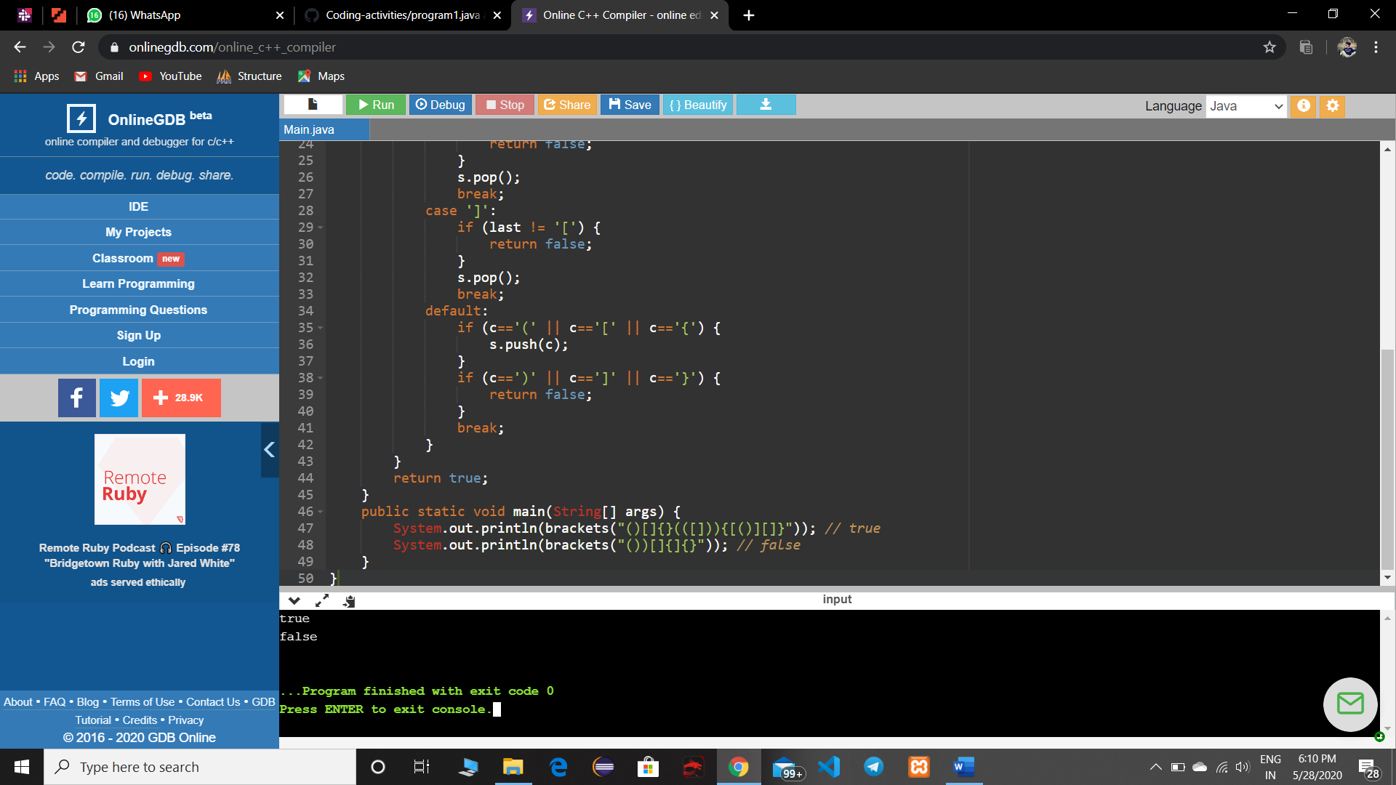

1. This python program is to get digit root of the number where we give a random number and until it become complete single digit it goes on calculate.

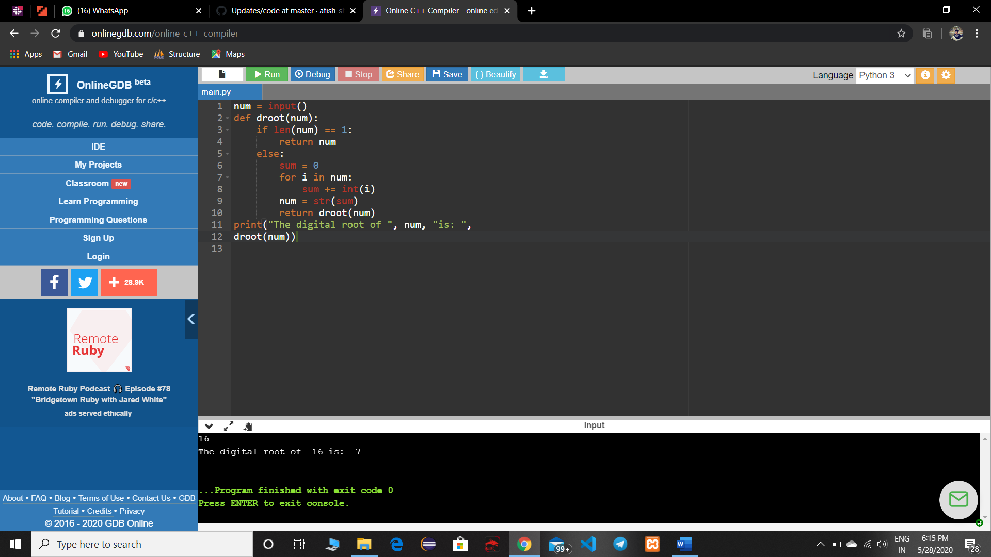

1. This c program prints last remaining element in array.

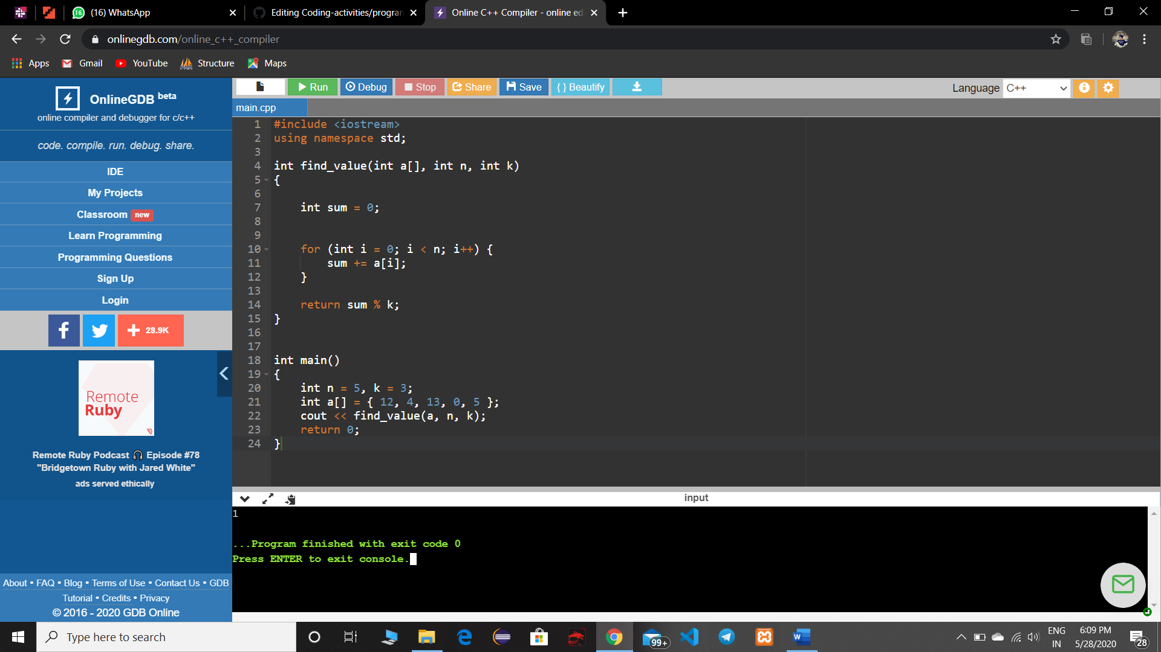

1. JSP program to print current date and time.

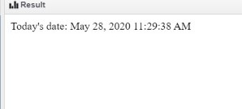

1. JSP program to print number of visitor visited the site.

